“We sincerely hope that you will enjoy
your experience at Lough Rynn Castle.
We look forward to welcoming you
back in the near future.”



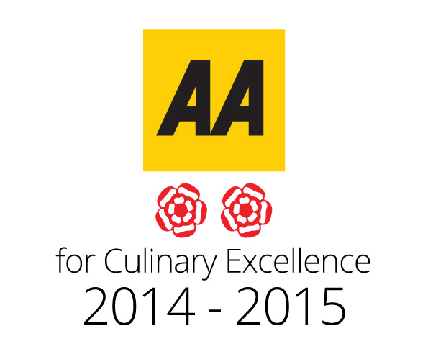


Lough Rynn Castle
Drawing Rooms
Menu

Served From
12.30 pm to 9pm
Afternoon Tea Served
1.00pm to 4pm

Afternoon Tea

Sandwich Assortment
Smoked Salmon Tartar (1,4,7,12)
Traditional Ham (1,12)
Chicken Caesar (1,12)
Red Onion + Cheddar (1,3,7)

Freshly Baked Orange Blossom &
Sultana Scone (1,3,7)
With Clotted Cream & Seasonal Preserves

Lemon Meringue (1,3,7)

Cheesecake (1,3,7)

Opera Cake (1,3,7)

Strawberry Gateaux (1,3,7)

Lemon Drizzle (1,3,7)

Bananna Bread (1,3,7)

Iced Carrot Cake (1,3,7,8)

Accompanied with Freshly Brewed Tea, Coffee or a Selection from our
Pukka Tea Range

€35.00 Per Person

Add a Glass of Prosecco
Or

An Aperol Spritz

€45.00 Per Person
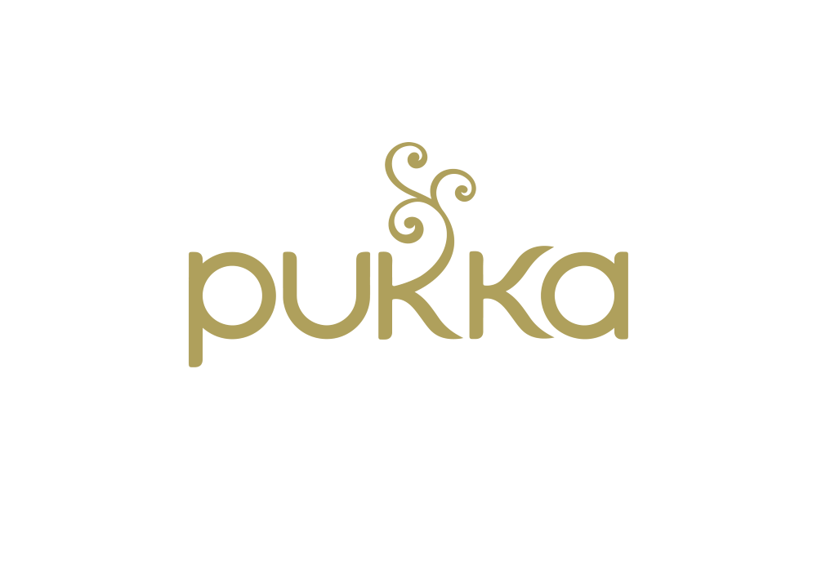
Hot Beverages
All Served with Homemade Cookies
Tea Selection €4.90

Choose from our range of Pukka Teas including;
Elegant English Breakfast, Night Time Berry, Peace, Three Mint, Supreme Matcha Green, Three Mint, Turmeric Active or Lemon, Ginger & Manuka Honey

Please ask your server to view our
Tea Menu for more information


Coffee Arabica
Freshly Brewed Coffee €4
Espresso €4
Cappucino €4.50
Latte €4.50
Pot of Tea or coffee €6.90
Hot Chocolate €4.50



Speciality Liquer Coffees

Irish Coffee (Whisky) (7) €8.50
Baileys Coffee (Baileys) (7) €8.50
Royal Coffee (Hennessy) (7) €8.50
Italian Coffee (Amaretto) (7) €8.50
Calypso Coffee (Tia Maria) (7) €8.50
Monk’s Coffee (Benedictine) (7) €8.50


Soft Drinks
Coca Cola €3.50
Diet Coke €3.50
Coke Zero €3.50
Sprite €3.50
Fanta Orange €3.50
Fanta Lemon €3.50
Appletiser €4.00

Light Bites

Buffalo Style Chicken Wings (1,8,9,10,12) €9.00
Blue Cheese Dip

Red Pepper Arancini (1,3,7,8,12) €8.50
Crispy Deep Fried Risotto Croquettes Flavoured with Red Pepper and Parmesan Served with a Red Pepper Romesco Sauce.

Chicken Caesar Salad (1,3,4,6,10,12) €10.60
Warmed Chicken Fillet, Bacon Lardons, Crunchy Croutons, Parmesan Shavings & Caesar Dressing

Lough Rynn Prawn Cocktail (1,2,3,4,7,10,12) €11.50
Served with a Classic Marie Rose Sauce,
Crisp Gem Lettuce, Smoked Paprika

Heirloom Tomato Salad (7,10,12) €9.95
Salad of Heirloom Tomatoes, Mixed Baby Leaves,
Wild Rice, St Tola Goats Cheese, Balsamic Dressing

Loaded House Fries (3,6,7,10.12) €7.95
Choose your filling:
-Shaved Parmesan & Truffle Mayo
-Smoked Bacon Pieces & Gubbeen Cheese
-Garlic Mayo Cheese

Soup & Sandwiches

Soup of the Day (6,7,9,12) €7.00
Served with Homemade Brown Soda Bread (1,7,12)

Lough Rynn Seafood Chowder (2,3,4,6,7,9,12,14)€9.00
A Medley of Irish Fish and Seafood Served in a Cream Sauce. & Served with Homemade Brown Soda Bread

Roasted Pepper & Tomato Soup (6,7,9,12) €7.50 Served with Homemade Brown Soda Bread (1,7,12)

Crispy Chicken Wrap (1,3,7,10,12) €11.50
Crispy Breaded Pieces of Chicken Breast with Garlic Mayonnaise, Baby Gem Lettuce and Plum Tomato

Tomato & Mozzarella Focaccia (1,3, 7, 10.12) €10.50
Sliced Tomato and Buffalo Mozzarella Layered with Basil Pesto and Mixed leaves.

Classic Club Sandwich (1,3,7,12) €14.60
Grilled Bacon, Sliced Chicken Breast, Egg, Tomato,
Iceberg Lettuce, Mayonnaise, Toasted &
Accompanied with House Fries
(Vegetarian option available)

For Your
Sweet Tooth…

Chocolate Fudge Sundae (1,3,7,8) €8.20
Bourbon Vanilla Ice Cream, Brownie Chunks and
Whipped Cream Served with Warm Chocolate Fudge Sauce

Assiette of Mini Desserts (1,3,7,12) €8.20
Chefs Selection

Sticky Toffee Pudding (1,3,7,8,12) €8.20 Butterscotch Sauce & Honeycomb Ice Cream

Fresh Berry Pavlova (3,7,12) €8.20
Crisp Meringue, a Medley of Fresh Summer Fruit and Chantilly Cream

Cheesecake of the Day (1,3,7,12) €8.20
Whipped Cream

Lough Rynn Scone (1,3,7,12) €3.90
Freshly Baked Orange & Sultana Scone or Plain Scone with Clotted Cream and Seasonal Preserves

Cheese Board (1,6,7,8,9,12 ) €18.50
Selection of Irish Farmhouse Cheeses. Please ask your server for details. Served with Crackers, Grapes & a Fruit Chutney

Allergy Advice

Before placing your order, please inform your waiter if you have a food allergy. Many of the items on our menus can be tailored to meet your dietary requirements.

(1) Cereals (8) Nuts
(2) Crustaceans (9) Celery
(3) Eggs (10) Mustard
(4) Fish (11) Sesame Seeds
(5) Peanuts (12) Sulphur Dioxide
(6) Soybeans (13)Lupin
(7) Milk (14) Molluscs

Main Courses

8oz Castle Deluxe Beef Burger (1,3,7,10,12) €19.95
Red Onion Marmalade, Gubbeen Cheddar,
Smoked Streaky Bacon, Rocket, Burger Dressing
With Seasoned House Fries

Fish and Chips (1,3,4,6,7,10,12) €19.95
Crispy Beer Battered Fillet of Cod,
Crushed Peas, Seasoned House Fries & Chunky Tartar Sauce

LR Flaming Chicken Sandwich (1,3,7,10,12) €18.50
Marinated Chicken Fillet with our own Blend of Herbs and Spices. Served on a Brioche Bun with Baby Gem & Plum Tomato, Seasonal House Fries

Slow Cooked Featherblade of Beef (7,12) €21.50
Served with Creamed Potato, Seasonal Vegetables and a Bourgignon Sauce.

Pan Fried Fish of the Day (4,7,12) €21.50
Served with a Niçoise Style Potato, Green Bean and Sundried Tomato Fricassee and a Saffron Velouté.

Campbell’s Sirloin Steak Sandwich €25.00
5oz Prime Leitrim Sirloin of Beef Served on a Toasted Ciabatta with Garlic Aioli, Sundried Tomato, Rocket, Crispy Onions and Seasonal House Fries (1,3,7,10)
Served with Pepper Sauce

Wild Mushroom & Pea Pappardelle (1,3,8) €18.50
Fresh Pappardelle Pasta with Sauteed Wild Mushrooms. &
Petit Pois in a White Wine Cream Sauce.

Sides
Creamed Potato (7) €4.50
Mixed Salad (12) €4.50
House Fries (1) €4.50
Seasonal Vegetables (7) €4.50
Garlic Mayo (3,10,12) €2.00
Sauteed Mushrooms (7) €4.00

nel Cream

